# CONSOLIDATED EXAM QUESTIONS

# RATES OF CHEMICAL REACTIONS

Contents

CONSOLIDATED EXAM QUESTIONS 1

RATES OF CHEMICAL REACTIONS 1

Syllabus 2

Rates of Reactions and Activation Energy – 18.1 3

2017 3

2022 3

2017 3

2022 4

Collision Theory – 18.2-18.3 5

2020 5

2021 6

2019 6

2020 6

Catalysts – 19.1 7

2018 7

2021 7

2020 7

# Syllabus

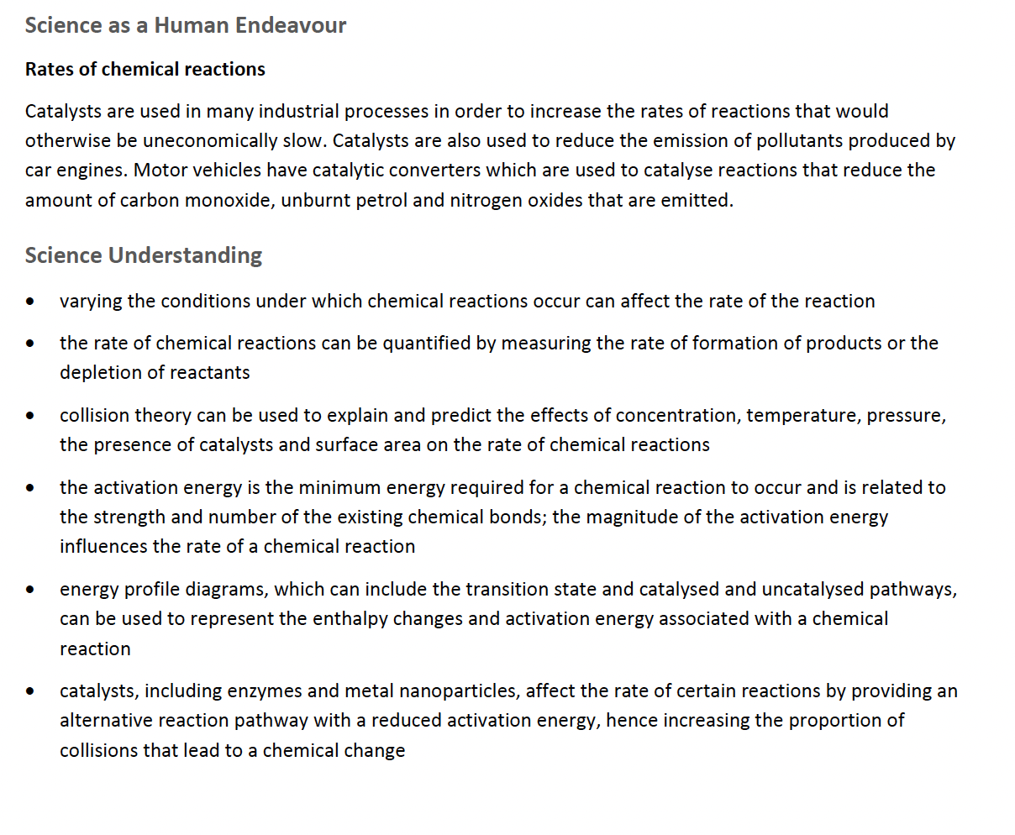

# Rates of Reactions and Activation Energy – 18.1

## 2017

## 2022

## 2017

## 2022

# Collision Theory – 18.2-18.3

## 2020

## 2021

## 2019

## 2020

# Catalysts – 19.1

## 2018

## 2021

## 2020